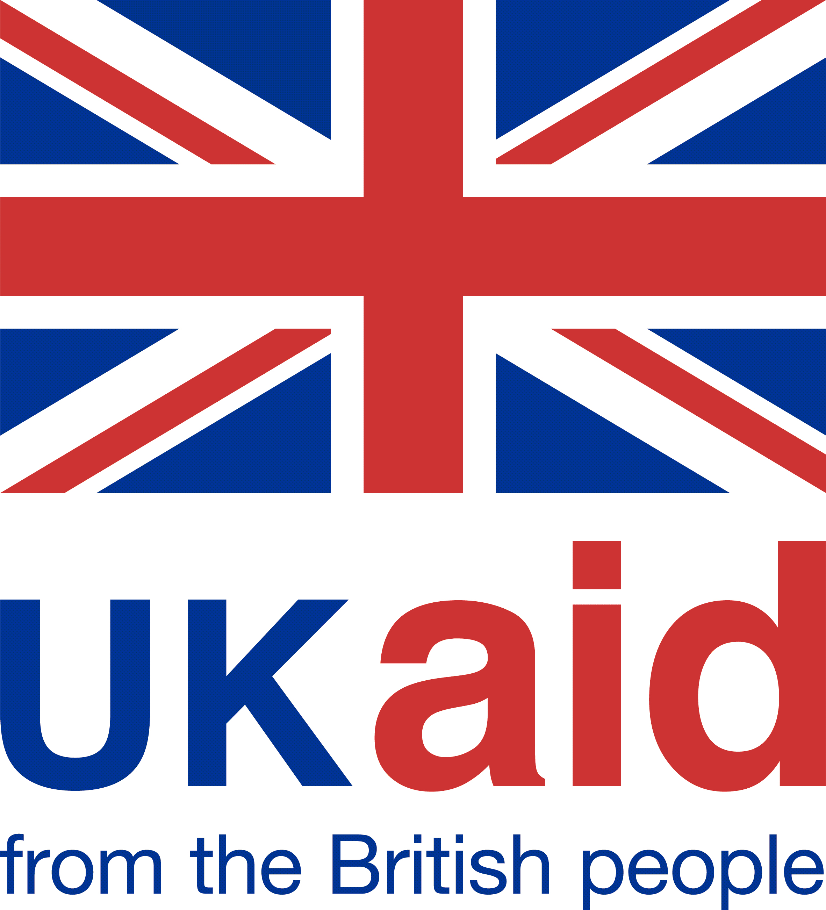
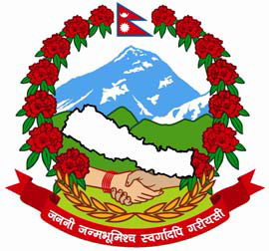
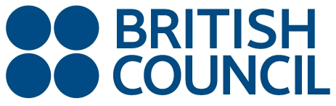

Request for Expression of Interest from Schools

Government of Nepal, Department of Education and British Council announces submission of expression of interest from schools in Nepal to participate in the International Schools Award for 2018-19

The British Council International School Award (ISA) is a benchmarking scheme that accredits and recognizes schools as having an outstanding level of support for embedding global themes into their curriculum and improving standards of education and teaching.

Working towards the award will link your school with partner schools across the globe so you can work together on joint curriculum projects that deal with global issues. Teachers benefit by sharing best practice with one another, so improving teaching and education standards in the school and country as a whole.

The award is open to any school, so what are you waiting for, don’t get left behind!

Eligibility criteria for participation:

Any recognized school offering any curriculum, government, semi-government, private and international is eligible to apply for ISA. The minimum requirements include basic infrastructure in the school, at least one computer with internet facility and at least one teacher with adequate working knowledge of the English language.

This award is endorsed by the Department of Education in Nepal since June 2012.

For further details, including the application, please refer to http://www.britishcouncil.org.np/programmes/education/connecting-classrooms
Completed application should reach the British Council office through email at connecting.classrooms@britishcouncil.org.np no later than 1700 hours on 15 April, 2018. British Council reserves the right to reject, the applications without assigning any reason or reasons whatsoever. Only selected schools will be invited to attend the orientation workshop.

