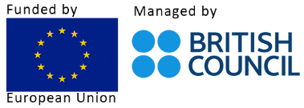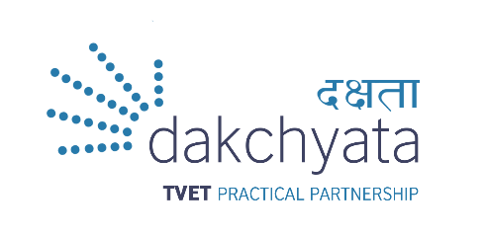

**Press Release**

**9 March 2022**

*For immediate release*

**Dakchyata enters partnership with UNDP, ILO and IOM to support skilling, reskilling and upskilling of returnee migrant workers affected by the pandemic**

The European Union (EU) funded and British Council managed *Dakchyata: TVET Practical Partnership* project awards grants totalling EUR 1.99 million to UNDP (United Nations Development Programme – NPR 117,623,000), ILO (International Labour Organisation Nepal – NPR 87,188,000) and IOM (International Organisation for Migration - NPR 59,711, 953) through the European Union Practical Partnership Fund. Activities under this grant scheme target trainers or trainees in three of the most important economic sectors in Nepal: Agriculture, Construction and Tourism, mobilising support from employers and their associations.

The projects aim to generate evidence on future skills needs, promote the upskilling of migrant workers, and identify new opportunities for migrant returnees to successfully reintegrate into the labour market. Its purpose is to build competencies of stakeholders and support returnee migrant workers and their families who were affected by the pandemic, through identifying skills and reskilling demands for sustainable reintegration and/or safe labour migration.

All three project partners have strong track records in successful delivery in relevant sectors in Nepal, building on existing programming for rapid mobilisation and start-up. These organisations are specialised in skills development, labour market, and migration support – including in areas of rights of migrants, social and economically reintegration of returning migrants, or skills training for decent jobs.

“The EU is proud to contribute to this action, which will create the basis for integrating returnee migrants in the Nepali labour force, with increased skills and better earning opportunities. This is a win-win for Nepal, and for the returnee migrants, by harnessing a strong workforce and providing dignified economic opportunities to migrants in their own communities” states Mrs Nona Deprez, the European Union's Ambassador to Nepal

Similarly, Dakchyata project team leader, Erik Winther-Schmidt said, “The Returning Migrant Workers grant fund is channelled to support a key challenge which emerged with the global pandemic, that is the reintegration of returnee migrant workers who bring with them a range of skills, not all of which may be officially recognised through qualifications and skills. Together with our partners, the three projects have been designed to be complementary to existing initiatives in the field, with the British Council/Dakchyata supporting to address key challenges in skilling returning migrant workers.”

**The three projects and related organisations’ statement on the grant award below:**

***Enhancing Returnee Migrant Workers Skills For Employment, UNDP***

Activities will be targeted at Province 2 and Province 5.

“From the onset of the global pandemic, migrants were exposed to infection, stigma, bias and were laid off from employment in vast numbers. Stranded, and on unpaid leave because of the risky environments and poor working conditions including lack of labour market protection in the type work they were involved in abroad. Therefore the ‘Enhancing Returnee Migrant Workers Skills for Employment’ project has been designed to analyse and match returnee migrants’ skills and competencies, providing relevant training according to market needs, certify their skills, coach, counsel, and mentor to effectively reintegrate at least 1500 people, prioritising women migrants. With this, it is expected that approximately 8000 people will benefit indirectly. Three key sectors are targeted: agriculture, construction, and tourism, particularly focusing on the scope to promote green jobs. As part of the government’s vision to create better employment opportunities for returnee migrant workers, it is hoped that the results of this project could be scaled up to all provinces. To be successful, these types of activities need collaboration on several fronts, and this is why we particularly value this important coalition among several partners, the Ministry of Education, the British Council and UNDP, with financial support from the European Union,” said UNDP Nepal Resident Representative Ms. Ayshanie Medagangoda-Labé.

***Generating Evidence for Future Skills Needs of Migrant Workers in Nepal, IOM***

This Project will be implemented at a nationwide level, aiming to generate evidence on future skills needs.

“As a 2020 IOM study has found that education and skills were key factors for job security in countries of destination during the pandemic, through this project, IOM aims to generate evidence on future skills needs, promote upskilling of migrant workers, and identify new opportunities for migrant returnees,” said Lorena Lando, IOM Chief of Mission for Nepal. “This will contribute to better protection and economic opportunities for migrants and their families,” she added.

***Welcome Home: Enabling Economic Reintegration of Returnee Migrant Workers,* ILO**

According to Richard Howard, Director of the ILO Country Office for Nepal, " Within this broader collaboration, the ILO will support for the economic reintegration of returned Nepali migrant workers by improving their access to basic employment services; providing opportunities for up-skilling, re-skilling, skills certification; strengthening public-private sector dialogues, and strengthening selected municipalities' services for registration of returned migrant workers’ profile, also including their skills." The target districts for this project are Morang, Jhapa and Sunsari.

For further information, please contact the Dakchyata project at the following address:

[dakchyata@britishcouncil.org.np](mailto:dakchyata@britishcouncil.org.np)

­­­­­­­­­­­­­­­­­­­­­­­­­­­­­­­­­­­­­­­­­­­­­____________________________END_________________________________________