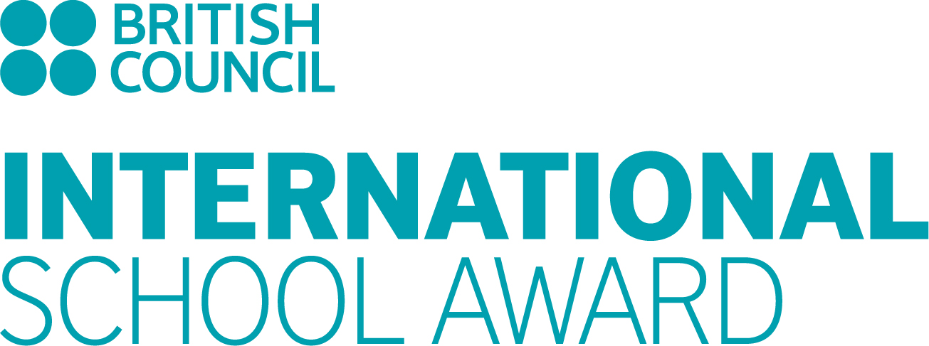

ACTION PLAN FORM
2019-20


ISA ACTION PLAN

Project 1
(Title mentioning the International dimension and brief description of the project):
Type: | Collaborative project with an international partner
SDG focus:

Minimum three Learning
Outcomes- at the end of the
activity the students will be able to (Write in terms of Knowledge and Skills):
Brief and clear description of Activity that will help in attaining the projected learning outcomes (at least one activity for each learning outcome)
Month and duration of activity
Classes / no. of pupils involved
Countries covered
Subjects covered with curriculum link
Teachers responsible
Evaluation methods to measure the learning outcome among the pupils
Evidences to be provided in the portfolio

Project 2
(Title mentioning the International dimension and brief description of the project):
Type: | Collaborative project with an international partner
SDG focus:

Minimum three Learning
Outcomes- at the end of the
activity the students will be able to (Write in terms of Knowledge and Skills):
Brief and clear description of Activity that will help in attaining the projected learning outcomes (at least one activity for each learning outcome)
Month and duration of activity
Classes / no. of pupils involved
Countries covered
Subjects covered with curriculum link
Teachers responsible
Evaluation methods to measure the learning outcome among the pupils
Evidences to be provided in the portfolio

Project 3
(Title mentioning the International dimension and brief description of the project):
Type: | Collaborative project with an international partner
SDG focus:

Minimum three Learning
Outcomes- at the end of the
activity the students will be able to (Write in terms of Knowledge and Skills):
Brief and clear description of Activity that will help in attaining the projected learning outcomes (at least one activity for each learning outcome)
Month and duration of activity
Classes / no. of pupils involved
Countries covered
Subjects covered with curriculum link
Teachers responsible
Evaluation methods to measure the learning outcome among the pupils
Evidences to be provided in the portfolio

Project 4
(Title mentioning the International dimension and brief description of the project):
Type: | Collaborative project with an in-country partner (public/private partnership)
SDG focus:

Minimum three Learning
Outcomes- at the end of the
activity the students will be able to (Write in terms of Knowledge and Skills):
Brief and clear description of Activity that will help in attaining the projected learning outcomes (at least one activity for each learning outcome)
Month and duration of activity
Classes / no. of pupils involved
Countries covered
Subjects covered with curriculum link
Teachers responsible
Evaluation methods to measure the learning outcome among the pupils
Evidences to be provided in the portfolio

Project 5
(Title mentioning the International dimension and brief description of the project):
Type: | 20% Local Curriculum project with an international dimension
SDG focus:

Minimum three Learning
Outcomes- at the end of the
activity the students will be able to (Write in terms of Knowledge and Skills):
Brief and clear description of Activity that will help in attaining the projected learning outcomes (at least one activity for each learning outcome)
Month and duration of activity
Classes / no. of pupils involved
Countries covered
Subjects covered with curriculum link
Teachers responsible
Evaluation methods to measure the learning outcome among the pupils
Evidences to be provided in the portfolio

Project 6
(Title mentioning the International dimension and brief description of the project):
Type: | In-school project with international dimension
SDG focus:

Minimum three Learning
Outcomes- at the end of the
activity the students will be able to (Write in terms of Knowledge and Skills):
Brief and clear description of Activity that will help in attaining the projected learning outcomes (at least one activity for each learning outcome)
Month and duration of activity
Classes / no. of pupils involved
Countries covered
Subjects covered with curriculum link
Teachers responsible
Evaluation methods to measure the learning outcome among the pupils
Evidences to be provided in the portfolio

Project 7
(Title mentioning the International dimension and brief description of the project):
Type: | In-school project with international dimension
SDG focus:

Minimum three Learning
Outcomes- at the end of the
activity the students will be able to (Write in terms of Knowledge and Skills):
Brief and clear description of Activity that will help in attaining the projected learning outcomes (at least one activity for each learning outcome)
Month and duration of activity
Classes / no. of pupils involved
Countries covered
Subjects covered with curriculum link
Teachers responsible
Evaluation methods to measure the learning outcome among the pupils
Evidences to be provided in the portfolio

Project 8
(Title mentioning the International dimension and brief description of the project):
Type: | Any Supplementary project (not mandatory)
SDG focus:

Minimum three Learning
Outcomes- at the end of the
activity the students will be able to (Write in terms of Knowledge and Skills):
Brief and clear description of Activity that will help in attaining the projected learning outcomes (at least one activity for each learning outcome)
Month and duration of activity
Classes / no. of pupils involved
Countries covered
Subjects covered with curriculum link
Teachers responsible
Evaluation methods to measure the learning outcome among the pupils
Evidences to be provided in the portfolio

