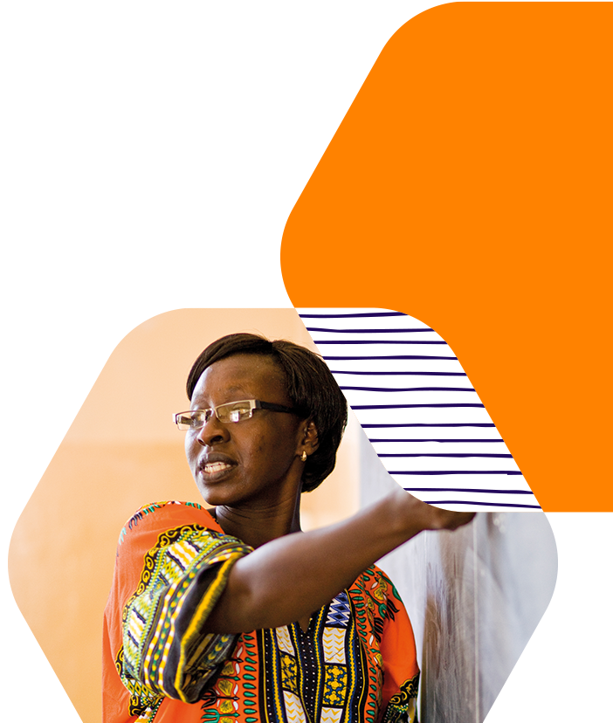

Cultural Engagement
Terms of Reference (ToR)

Endline Study

September 2026

Overview of the British Council
The British Council is the UK’s international organisation for cultural relations and educational opportunities. We support peace and prosperity by building connections, understanding and trust between people in the UK and countries worldwide. Through our arts, education and English programmes, we give opportunities to hundreds of millions of people worldwide each year. We are on the ground in six continents and over 100 countries. The British Council has been operating in Nepal since 1959.

In Nepal, the British Council has been working with the Ministry of Education and Sports (MoES) and other education agencies for 67 years to support systemic reforms in the education sector. Our priorities in the education sector include school education, English language teaching and learning, non-formal education, and Technical and Vocational Education and Training (TVET).

Background
The School Education Sector Plan 2021-2030 (SESP) highlights the curriculum framework provision of using mother tongue and/or local languages in a multilingual context to facilitate learning so that the medium of instruction used in the classroom corresponds to the learners’ home language and does not present a barrier in learning. The SESP also shows 4.9 per cent of 5–12-year-olds remaining out-of-school despite Nepal’s commitment to ensuring free and compulsory basic education for all. The data also shows continued disparity in access and learning outcomes for girls from lower socio-economic backgrounds, children with disability and children whose mother tongue is not Nepali (British Council 2019; Hultgren et al; SESP 2022; USAID 2017, World Vision 2022).
Multilingualism is imperative for achieving all sustainable development goals and the British Council’s wealth of data shows that children’s participation in well-designed multilingual education programmes underpins learning in all subjects, including English, through the use of the mother tongue or a familiar indigenous language. Therefore, the British Council, in partnership with UNICEF, has implemented a programme to support the Government of Nepal’s goals for sustainable improvements in foundational learning as per School Education Sector Plan (SESP), Consolidated Equity Strategy 2014 and roadmap on inclusive education through series of interventions that will improve children’s access to effective and inclusive education through a holistic approach working across multiple levels of the system.
The Programme
The British Council has partnered with UNICEF to build a programme to support the Government of Nepal’s goals for sustainable improvements in inclusive education. The programme, Strengthening quality inclusive early learning and institutional capacity within the Nepal’s school education sector, seeks to support the Government’s School Education Sector Plan (SESP), Consolidated Equity Strategy 2014 and roadmap on inclusive education through a series of interventions that will improve children’s access to effective and inclusive education through a holistic approach working across multiple levels of the system. The programme’s objectives are to support system strengthening for promoting quality and inclusive education; and strengthening institutional capacity in local governments to ensure quality and inclusive access to early grade learning within their schools.
The scope of the partnership programme includes developing policy guidelines on languages in education, resource development for supporting multilingual education in early grades, supporting on teacher training, professional development, and teacher support systems for the enhancement of foundational literacy and numeracy (FLN) through the integrated curriculum implementation support. The programme activities are being implemented across the selected LGs of Madhesh, Lumbini, Karnali and Sudurpaschim provinces of Nepal.
The British Council seeks to engage a consulting agency to conduct an Endline Study for the programme “Strengthening quality inclusive early learning and institutional capacity within the Nepal’s school education sector”, to assess improvements in learning outcomes for girls and boys at grades 1-3.
The programme aims to improve the learning outcomes for girls and boys through the following intermediate outcomes:
- Improved use of integrated and multilingual pedagogies to improve Foundational Literacy and Numeracy (FLN) skills among early grade children
- Improved teaching learning and professional development practices of teachers from Grade 1-3.
Objectives of the assignment
The endline study findings will provide evidence and measure the changes in foundational literacy and numeracy outcomes among girls and boys in early grades (Grades 1–3), using updated EGRA and EGMA tools along with exploring the teacher development practices in grade 1-3 for foundational learning. This study also highlights the evidence on gender and inclusion areas with focus to student learning, and teacher development.
The objectives of the assignment are:
- To coordinate with ERO, UNICEF and British Council to finalize the endline assessment tools.
- To coordinate with ERO and manage logistics for training and/or refresher training to enumerators on the assessment tools
- To conduct the Endline study in the targeted palikas and schools in coordination with ERO, British Council and UNICEF
- To produce an Endline Study Report that uses both quantitative and qualitative data collection techniques to collect relevant information from the respondents and produce a comparative final report of baseline and endline in terms of gender, inclusion, provinces, LGs and as relevant.
Scope of Work
Specific tasks for the assignment include:
- Form a multidisciplinary assessment team with strong expertise in conducting evaluation studies with extensive experience in the education sector.
- Design a sampling frame of areas in close consultation with the British Council and UNICEF
- Convene inception workshop with the British Council, UNICEF, DoE, ERO, to review the overall assessment approach, tools, methodology, field visit plan, data management & analysis plan, deliverables, and timeline.
- The Consulting Agency is expected to follow the tools shared by Education Review Office (ERO) for the Early Grade Reading Assessment (EGRA) and Early Grade Mathematical Assessment (EGMA).
- Develop criterion for enumerators selection. While recruiting enumerators, priority should be given to recruit enumerators who have prior experience in conducting EGRA, EGMA or similar learning assessment tests, wherever possible
- The Consulting Agency is responsible for coordination with the ERO on determining the instruments to be used for the assessment which will include (but not be limited to) interviews/semi-structured interviews and/or classroom observation tools with school level stakeholders (e.g. Head Teachers, Teachers, SMC members) and local government representatives (e.g. Education Unit).
- Prepare enumerators training guidelines and materials and conduct training for enumerators (3-4 days as required) in coordination with ERO
- Develop a detailed field visit plan with the composition of team members in close consultation with British Council and UNICEF and include it in the data collection guideline.
- Organize data collection as well as consultation meetings with all relevant stakeholders.
- Collect quality data as per the data collection protocol/guideline and supervise data collection, including spot-checking, and manage daily review of status of data collection.
- Conduct quality assurance audit and document lessons learned from the implementational experiences.
- Update British Council and UNICEF regarding field progress on agreed frequency using a standard reporting format. Conduct daily quality checks to verify data, cleaning, and feedback to the enumerators.
- Anonymize datasets to ensure no personally identifiable data information is linked to individual records. Ensure data are backed-up and stored on password-protected secure computers and cloud servers. Conduct necessary data cleaning, coding and produce a working anonymized dataset.
- Analyse and interpret assessment data according to the agreed analysis plan by provinces, LGs, gender, and inclusion and other relevant categories.
Methodology:
- The study should employ a mixed methods research design. The Consulting Agency should define the research design that will be implemented in the Endline Study, especially at local levels. The study should involve systematic integration of quantitative and qualitative data collection techniques including EGRA/EGMA tests, classroom observations, record reviews and reviews of existing secondary data, wherever applicable.
- The population for this study consists of 378 schools of 19 districts and 25 local governments across 4 provinces (Lumbini, Madhesh, Karnali and Sudurpaschim). The consulting agency is expected to propose a statistically significant sample (at least 33%) for all the four provinces which will allow for inter-province comparison as well as allow for generalization of the data generated. The following are the LGs planned to cover in the evaluation.
S.N. | Province | District | Local Government
1 | Karnali | Dailekh | Narayan Municipality
2 | Karnali | Kalikot | Khandachakra Municipality
3 | Karnali | Kalikot | Raskot Municipality
4 | Karnali | Kalikot | Sanni Tribeni Rural Municipality
5 | Karnali | Mugu | Chhayanath Rara Municipality
6 | Karnali | Surkhet | Simta Rural Municipality
7 | Karnali | Salyan | Tribeni Rural Municipality
8 | Lumbini | Rupandehi | Marchawari rural municipality
9 | Lumbini | Kapilvastu | Maharajgunj Municipality
10 | Lumbini | Kapilvastu | Shivraj Municipality
11 | Madhesh | Bara | Kolhabi Municipality
12 | Madhesh | Parsa | Pakahamainpur Rural Municipality
13 | Madhesh | Rautahat | Chandrapur Municipality
14 | Madhesh | Sarlahi | Lalbandi Municipality
15 | Madhesh | Mahottari | Bhangaha Municipality
16 | Madhesh | Siraha | Karjanha Municipality
17 | Madhesh | Siraha | Siraha Municipality
18 | Madhesh | Dhanusha | Mithila Municipality
19 | Madhesh | Sarlahi | Hariyon Municipality
20 | Madhesh | Siraha | Golbazar Municipality
21 | Sudurpaschim | Darchula | Mahakali Municipality
22 | Sudurpaschim | Dadeldhura | Ajayemeru Rural Municipality
23 | Sudurpaschim | Kailali | Bhajani Municipality
24 | Sudurpaschim | Kailali | Kailari Rural Municipality
25 | Sudurpaschim | Kanchanpur | Laljhandi Gaunpalika

- The sources of data for this study will be primary data. Secondary data particularly the baseline/midline will be available through the British Council/UNICEF while Govt. Data from DOE and ERO. The sources of primary data will be early grade teachers, head teachers, parents and students at sample schools and other key informants.
- The Consulting Agency will analyse data by using appropriate statistical tools and methods with strong justification.
- The Consulting Agency will generate evidence and recommendations to inform possible pathways and directions for improving foundational learning and provide direction on foundational learning with reference to the assessment of learning in boys’ and girls’ EGRA and EGMA scores in target schools.
Key Performance Indicators:
Intermediate Outcome 1  Improved student learning in foundational literacy and numeracy of grade 1-3 | % increase in average EGRA scores among Grade 1-3 students.  % increase in average EGMA scores among Grade 1-3 students.  Reduction in gender disparities in EGRA and EGMA achievement scores.  Improvement in learning outcomes among children from non-Nepali mother tongue backgrounds.
Intermediate Outcome 2  Improved use of integrated and multilingual pedagogies to enhance Foundational Literacy and Numeracy (FLN) skills in grade 1-3 | % of male and female teachers who have enhanced knowledge and skills on integrated and multilingual pedagogies, and teaching FLN from respective LGs.  % increase in male and female teachers applying integrated and multilingual techniques and FLN teaching skills in early grades from respective LGs.  Qualitative evidence of teachers implementing integrated pedagogy and learner-centred approaches in multilingual contexts.
Intermediate Outcome 3  Improved teaching, learning, and professional development practices of teachers from Grade 1-3. | Improved teacher knowledge and skills in implementing integrated teaching and learning approaches in the classroom  Improved teacher engagement in continuous professional development activities

Deliverables
The Consultant is expected to deliver the following:
- Inception Report and Workplan, that will include field plan, design of instruments and timeline (20%)
- Field Workplan- Team Leader for the Study and Approval of the Tools with ERO, Orientation/Training/Refresher Training to Enumerators (20%)
- Data Analysis and Draft Report Submission- Field level data collection, Submission of transcribed data, Presentation of initial key findings and addressing any feedback and/or comments (45%)
- Final Endline Report submitted with the British Council, UNICEF and ERO (15%)
Deliverables are expected to be completed in coordination with International Consultant alongside collaboration with the ERO.
Duration of Consulting Services
The consulting services will be from 15 Oct 2026 to 28 Dec 2026.
Tasks | By 9 Oct 2026 | By 27 Oct 2026 | By 5 Nov 2026 | By 20 Nov 2026 | By 10 Dec 2026 | By 15 Dec 2026 | By 28 Dec 2026
Selection of Consulting Agency
Inception Workplan
Tools Review, Design and Development
Meeting with ERO
Training of Assessor and Field Preparation
Field Work and Data Collection
Data Coding and Analysis
Report Writing
Submission of Draft Report |  |  |  |  |  |  | 25 Dec
Final Study Report |  |  |  |  |  |  | 28 Dec
(Note: The timeline may be revised upon the mutual agreement among the British Council, UNICEF, ERO and the Consulting Agency).
Consulting Agency Specifications
- At least 5 years of experience of conducting research and evaluation studies in the education sector, particularly within school education sector.
- Demonstrated experience of working across all the tiers of the government for research and evaluation.
- Experience of working with development partners, particularly in the education sector will be an added advantage.
- Preference will be given to agencies that have trained personnel in EGRA and EGMA tools.
Implementation arrangement
The Consulting Agency will work closely with the British Council, UNICEF and ERO along with the programme’s identified Task Force members during the endline Study process.

Application
Interested Consulting Agencies should submit the Supplier Response Template and required documents to consultant@britishcouncil.org.np no later than 11 October 2026.

The tasks may be mutually adapted during the planning stage of needs assessment based on comments from DOE, ERO and UNICEF.

